Chapter 9, Solution 93.

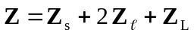
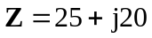

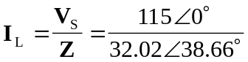

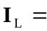 3.592–38.66 A

